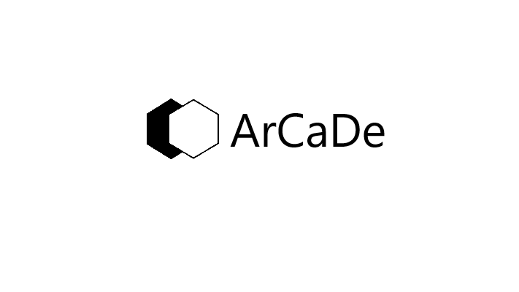

™

A MaN’s ArCaDe VPN Subscription

**Pay less and get more**

Have you ever been wandering why your Netflix doesn’t have all the millions of Interesting shows and movies that you see in movies and ads? Or why you run out of movies or series to watch so quickly? Well it’s simple. Netflix Geoblocks a huge amount of shows then charges you for the few movies and shows that they make available to your country. And many Geoblocked shows never end up in other countries

Use our VPN subscription now to unlock a whole new world of Netflix, Claiming access to the movies and shows available to all other countries like USA, UK, Korea, Spain, France etc. You are allowed to connect to up to all your personal devices Sharing your account with someone else mayleave your details Vunerable!

You are part of this Man’s arcade members only discount

For only **₦1499** a month (More than **60% off** forever) it’s so affordable only because we care about your privacy in these hard times.

To make it easier for you to become a member your payment with airtime, Cash or Transfer is accepted.

Earn discounts on holidays, For an early dive in You can get a free trial

Contact us at Musthyds@gmail.com to Learn more.

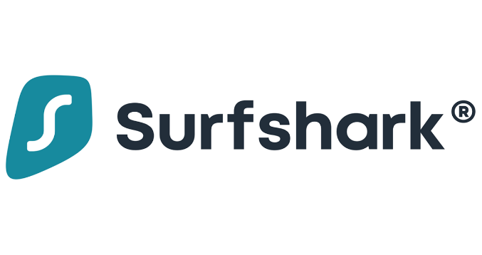

What exactly is a VPN?

Well unlocking all the hidden Contents from Netflix and other streaming services is barely a Dent of what you could benefit from a VPN. VPNs stand for Virtual Private Network, what this means is that VPN’s build a barreer between you and cyber criminls or websites that want to steal your information and could even be used to stop those annoying pop-up ads disturbing your browsing. Vpns also give you access to Popular websites that are only available to Specific countries or regions of the world as the VPN wall would Basically trick the network into thinking that you are browsing from that region.

VPN also log you into fast servers that enhance your internets speed. Yes! I said it would literally make your internet speed faster.Did you know that companies like facebook make millions of dollars every day by selling your Stolen data and every year Billions of Dollars are robbed from hardworking people that didn’t see the relevance of a VPN, and that is why all succesful celebrities secretly use VPN’s in their offices and also why we are giving you this exclusive 60% off lifetime offer to protect you and your entire extended families finances at the click of a button.

Every year that goes bye there are millions of new ways to hack into innocent peoples accounts and hundreds of milions of new victims just like you. So join the Billions of users that boast access to a VPN and you could go through your day feeling rest assured that your loved ones wont be the next victims while also enjoying the benefits that it has to offer.

Registration Form

**arcadevpnuser271204@gmail.com**



Scan for Password

QR code attached (Y/N)

First name:

Last name:

Date of Birth:

Nationality:

Country(ies) of residence:

City of residence:

Signature:

Referral code:

Phone number: + ( )

Your User ID is

To Request refferal code contact us at: [Musthyds@gmail.com](mailto:Musthyds@gmail.com), we would get back to you between 5 to 30 business days.

Registration Form

**arcadevpnuser271204@gmail.com**

First name: Richard

Last name: Wopara

Date of Birth: 27/12/2004

Nationality: Nigerian

Country(ies) of residence: Nigeria, Canada

City of residence: Port-Harcourt

Signature:

Referral code:

Phone number: +2 3 4 (8 0 8 7 1 1 3 0 3 9 )

Your User ID is

To Request refferal code contact us at: [Musthyds@gmail.com](mailto:Musthyds@gmail.com) we would get back to you between 5 to 30 business days.

Get Mans arcade User ID : eg, arcadeuserA500456

Scan for Password



F1Richard



QR code Attached

(Y/N)

MaN’s ArCaDe Reciept

Users Name: Tim Jobs

User ID: arcadeuser1@gmail.com

Platform: Surfshark VPN

Amount: ₦1499 only

(₦500 off for 2 years per active invite)

Transaction method: Airtime transfer

Date: Dec 19th, 10:25am (Today)

Next billing date: Jan 19th (monthly)



MaN’s ArCaDe Reciept

Users Name: Jack Cook

User ID: arcadeuser2@gmail.com

Platform: Surfshark VPN

Amount: ₦500 only (on Discount)

(₦500 off for 2 years per active invite)

Transaction method: PayPal transfer

Date: Dec 19th, 10:25am (Today)

Next billing date: Jan 19th (monthly)



MaN’s ArCaDe Reciept

Users Name:

User ID: arcadeuser3@gmail.com

Platform: Surfshark VPN

Amount: $8 (USD) only

($2 (USD) off for 2 years per active invite)

Transaction method: Bank transfer

Date: Dec 19th, 10:25am (Today)

Next billing date: Jan 19th (monthly)



MaN’s ArCaDe Reciept

Users Name:

User ID: arcadeuser4@gmail.com

Platform: Surfshark VPN

Amount: $8 (CAD) only

($2 (CAD) off for 2 years per active invite)

Transaction method: PayPal

Date: Dec 19th, 10:25am (Today)

Next billing date: Jan 19th (monthly)



MaN’s ArCaDe Reciept

Users Name:

User ID: arcadeuser5@gmail.com

Platform: Surfshark VPN

Amount: £8 only

(£2 off for 2 years per active invite)

Transaction method: Bank transfer

Date: Dec 19th, 10:25am (Today)

Next billing date: Jan 19th (monthly)



MaN’s ArCaDe Reciept

Users Name:

User ID: arcadeuser6@gmail.com

Platform: Surfshark VPN

Amount: €8 only

(€ 2 off for 2 years per active invite)

Transaction method: Cash App

Date: Dec 19th, 10:25am (Today)

Next billing date: Jan 19th (monthly)

